 | Faculty of Information Technology  H A N O I U N I V E R S I T Y

61FIT3NPR – Network Programming

Install Java and URL/URI in Java

A. INSTALL JAVA
I. INSTALL INTELLIJ IDEA
If you don’t want to use Eclipse, you can choose another IDE like IntelliJ IDEA.
Step 1: Download IntelliJ IDEA
https://www.jetbrains.com/idea/download/?section=windows
You should choose Community edition.
Step 2: Extract and install IntelliJ IDEA
II. USING ECLIPSE
1. Download JDK, Eclipse
1.1. JDK:
JDK is Java Development Kit which include JRE (Java Runtime Environment). Choose version that is compatible to your OS.
http://www.oracle.com/technetwork/java/javase/downloads/jdk8-downloads-2133151.html
1.2. Eclipse IDE for Java EE Developers:
Choose version that is compatible to your OS and JDK downloaded above. For lab computer, choose Windows 32 bit file.
https://www.eclipse.org/downloads/packages/release/photon/r/eclipse-ide-java-ee-developers
2. Install JDK, Eclipse
2.1. Install JDK:
Step 1: Run jdk.exe file or Extract jdk.rar file to a folder on your hard drive, for example, C:\Program Files\Java\jdk1.8.0_181 ‬‬‬‬‬‬‬
Step 2: Set environment variable:
In Windows, right click on This PC -> choose Properties -> choose Advanced system settings.
or go to Control Panel -> System and Security -> System -> choose Advanced system settings.
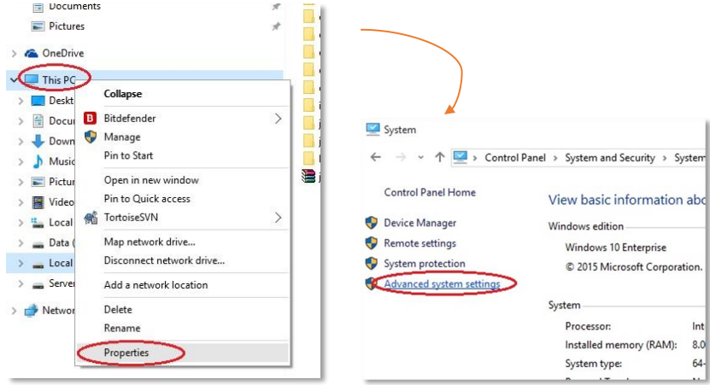
In System Properties dialog, choose Environment variables.
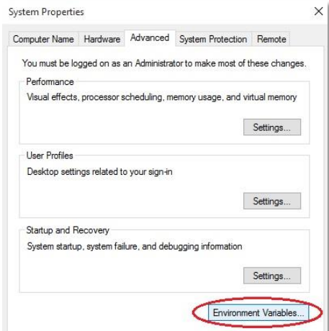
In System variables, Add new variable (or edit if already exist one) with Variable name JAVA_HOME and Variable value is your path to jdk folder.
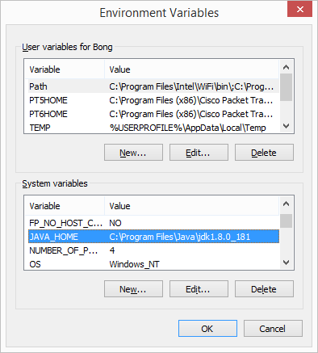
In System variables, also go to edit variable PATH, add ‬‬‬‬‬‬‬
C:\Program Files\Java\jdk1.8.0_181\bin;C:\Program Files\Java\jre1.8.0_181\bin
at the end of Variable value.
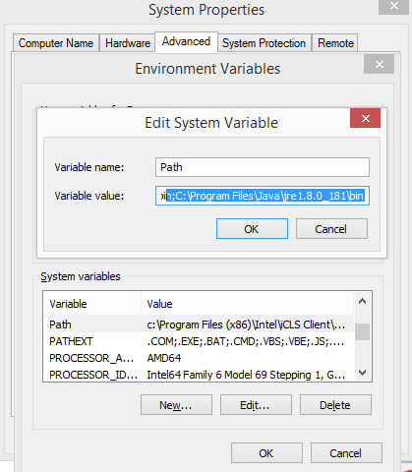
2.2. Install Eclipse:
Step 1: Extract the zip file to a folder on your hard drive, for example, E:\Java
Step 2: Go to the folder you have extracted and run eclipse.exe

B. FIRST PROGRAM
- Parsing an URL
String getProtocol()
String getHost()
int getPort()
String getFile()
String getRef()

import java.net.* ;
public class ParseURL {
public static void main(String[]args) throws MalformedURLException {
URL url = new URL("http://java.sun.com:80/docs/books/tutorial/intro.html#DOWNLOADING") ;
System.out.println("Protocol = "+url.getProtocol()) ;
System.out.println("Host = "+url.getHost()) ;
System.out.println("FileName = "+url.getFile()) ;
System.out.println("Port = "+url.getPort()) ;
System.out.println("Reference= "+url.getRef()) ;
}
}

- Reading directly from a URL using openStream() method that returns an InputStream
Here is an example that reads a URL directly. It actually reads from the Internet and displays it line by line to the console. Notice that it reads the file as a text file, so we simply get the HTML code. Also, you must be connected to the internet to run this code:
Example:
import java.net.* ;
import java.io.* ;
public class URLReader {
public static void main(String[] args) throws Exception {
URL url = new URL("https://www.hanu.vn") ;
BufferedReader br = new BufferedReader (new InputStreamReader(url.openStream())) ;
String line ;
while ((line=br.readLine())!=null)
System.out.println(line) ;
br.close() ;
}
}

- Reading from a URL connection:
Example:

import java.net.* ;
import java.io.* ;
public class URLConnectionReader {
public static void main(String[] args) throws Exception {
URL url = new URL("https://www.hanu.vn") ;
URLConnection uc = url.openConnection() ;
BufferedReader br=new BufferedReader(new InputStreamReader(uc.getInputStream()));
String line ;
while ((line=br.readLine())!=null)
System.out.println(line) ;
br.close() ;
}
}

Here is a modification to the above example that reads the URL by making a URLConnection first. Since the tasks of opening a connection to a webpage and reading the contents may both generate an IOException, we cannot distinguish the kind of error that occurred. By trying to establish the connection first, if any IOExceptions occur, we know they are due to a connection problem. Once the connection has been established, then any further IOException errors would be due to the reading of the webpage data

import java.net.*;
import java.io.*;

public class URLConnectionReader2 {
public static void main(String[] args) {
URL url = null;
BufferedReader in = null;
try {
url = new URL("https://en.wikipedia.org/wiki/Computer_science");
} catch(MalformedURLException e) {
System.out.println("Cannot find webpage " + url); System.exit(-1);
}

try {
URLConnection aConnection = url.openConnection();
in = new BufferedReader(
new InputStreamReader(aConnection.getInputStream()));
}
catch (IOException e) {
System.out.println("Cannot connect to webpage " + url); System.exit(-1);
}
try {
// Now read the webpage file
String lineOfWebPage;
while ((lineOfWebPage = in.readLine()) != null) System.out.println(lineOfWebPage);
in.close(); // Close the connection to the net
} catch(IOException e) {
System.out.println("Cannot read from webpage " + url);
}
}
}

